**EXPERIMENT-2**

# AIM: To find wavelength of sodium light by using Newton’s Ring.

**APPARATUS:(I).**a nearly monochromatic source of light (source of sodium light) **(II).** a plano-convex lens **(III).** an optically flat glass plates **(IV).** a convex lens **(V).** a traveling microscope

**THEORY/FORMULA USED:** • Condition for formation of bright and dark fringes:

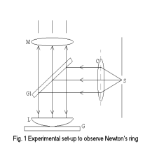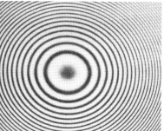

Fig. 1 Experimental setup to observe newton’s ring Fig. 2. Newton’s ring

When a parallel beam of monochromatic light is incident normally on a combination of a plano-convex lens C and a glass plate P, as shown in fig.1, a part of each incident ray is reflected from the lower surface of the lens, and a part, after refraction through the film between the lens and the plate, is reflected back from the surface of glass plate. These two reflected rays are coherent, hence they will interfere and produce a system of alternate dark and bright rings (see fig.2) with the point of contact between the lens and the plate at the center. These rings are known as Newton’s rings.

In general, the path difference between the reflected light beams which are undergoing interference (for oblique incidence) is given by

∆ = 2µtcosθ – λ/2 (1)

where additional path difference of λ 2 is because one of the interfering beam is reflected from film to glass surface. Also, θ is the angle of incidence. For normal incidence θ=0◦ and hence, the path difference will be

∆ = 2µt – λ/2 (2)

In the interference pattern bright fringe will be formed if the path difference is equal to integral multiple of wavelength of light, i.e.,

∆ = 2µt – λ/2 = nλ; n = 0, 1, 2, 3...

⇒ 2µt = (n + 1/2)λ; n = 0, 1, 2, 3... (3)

For intensity minima (dark fringe), ∆ = (n + 1/2)λ, and thus,

2µt = nλ. n = 0, 1, 2, 3… (4)

• Relationship between ring diameter and wavelength:

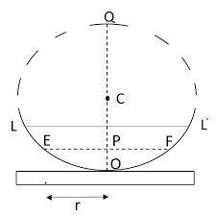

Figure 2

In fig.2, let LOL0 is the plano-convex lens placed on glass plate. Plano-convex lens appears as part of circle of radius R. Here, radius R is known as radius of curvature of plano-convex lens.

Suppose r is the radius of some n th bright ring having thickness t. Using the property of circle, from fig.(2), we can write

EP × P F = P O × P Q,

⇒ r2n = t × (2R − t),

⇒ r2n = (2Rt − t2).

Since R >> t, t 2 can be neglected therefore

r2n= 2Rt, (5)

by using Eq.(4) and Eq.(5), we have

r2n = (nλR)/µ . (6)

Using rn= Dn/2 , we can write following relation for diameter of n th, ring

D2n = 2r2n = (nλR)/µ . (7)

The diameter of some mth dark fringe will be

D2m = (mλR)/µ . (8)

Subtracting Eq.(7) and Eq.(8), we can write following relation

λ = [(D2n − D2m)/ 4R(n − m)] µ (9)

Above equation is used to find the wavelength of monochromatic light using Newton ring’s method, in which material of refractive index µ is immersed between plano-convex lens and glass plate. If air is enclosed as thin film having µ=1, then Eq.(9) becomes

λ = [(D2n − D2m)/ 4R(n − m)] (10)

The radius of curvature, R is calculated by spherometer (see fig.3) using following relation

R = (l2/ 6h) + h/2 .

**OBSERVATION:**

Vernier constant for the horizontal scale of the microscope (Least Count)=0.001cm

Radius of lens=100cm

**Table 1 Measurements of the diameter of the ring**

|  |  |  |  |  |  |  |  |  |  |
| --- | --- | --- | --- | --- | --- | --- | --- | --- | --- |
| Ring No. (n) | Microscope readings (cm) on the | | | | | | Diameter  Dn+m=  R2-R1(cm) | D2m+n  (cm2) |  |
| Left (R1) | | | Right (R2) | | |  |
| Main  Scale | Vernier | Total | Main scale | Vernier | Total | In cm2 |
| n+10 | 2.20 | 0.008 | 2.208 | 2.70 | 0.010 | 2.710 | 0.502 | 0.2520 |  |
| n+9 | 2.20 | 0.007 | 2.207 | 2.65 | 0.035 | 2.685 | 0.478 | 0.2284 | D2n+10 – D2n+9=0.0236 |
| n+8 | 2.20 | 0.030 | 2.230 | 2.65 | 0.033 | 2.683 | 0.453 | 0.2053 | D2n+9 – D2n+8 =0.0231 |
| n+7 | 2.25 | 0.001 | 2.251 | 2.65 | 0.023 | 2.673 | 0.422 | 0.1786 | D2n+8 – D2n+7 =0.0230 |
| n+6 | 2.25 | 0.009 | 2.259 | 2.60 | 0.039 | 2.639 | 0.380 | 0.1444 | D2n+7 – D2n+6 =0.0237 |
| n+5 | 2.25 | 0.030 | 2.280 | 2.60 | 0.024 | 2.624 | 0.344 | 0.1183 | D2n+6 – D2n+5 =0.0261 |
| n+4 | 2.30 | 0.000 | 2.300 | 2.60 | 0.008 | 2.608 | 0.308 | 0.0948 | D2n+5 – D2n+4 =0.0235 |
| n+3 | 2.30 | 0.016 | 2.316 | 2.55 | 0.036 | 2.586 | 0.270 | 0.0729 | D2n+4 – D2n+3 =0.0219 |
| n+2 | 2.35 | 0.000 | 2.350 | 2.55 | 0.014 | 2.564 | 0.214 | 0.0457 | D2n+3 – D2n+2 =0.0272 |
| n+1 | 2.35 | 0.023 | 2.373 | 2.50 | 0.030 | 2.530 | 0.157 | 0.0246 | D2n+2 – D2n+1 =0.0211 |

**CALCULATION:**

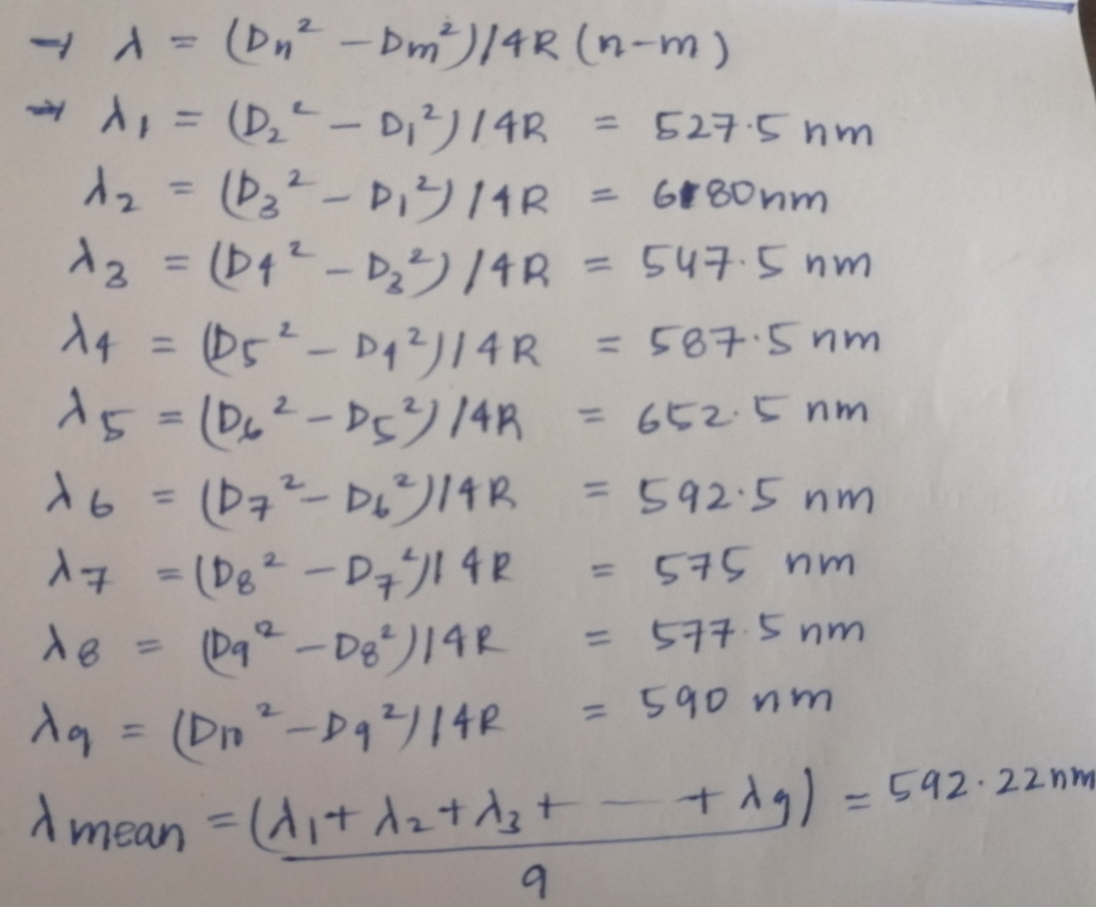

**PERCENTAGE ERROR:**

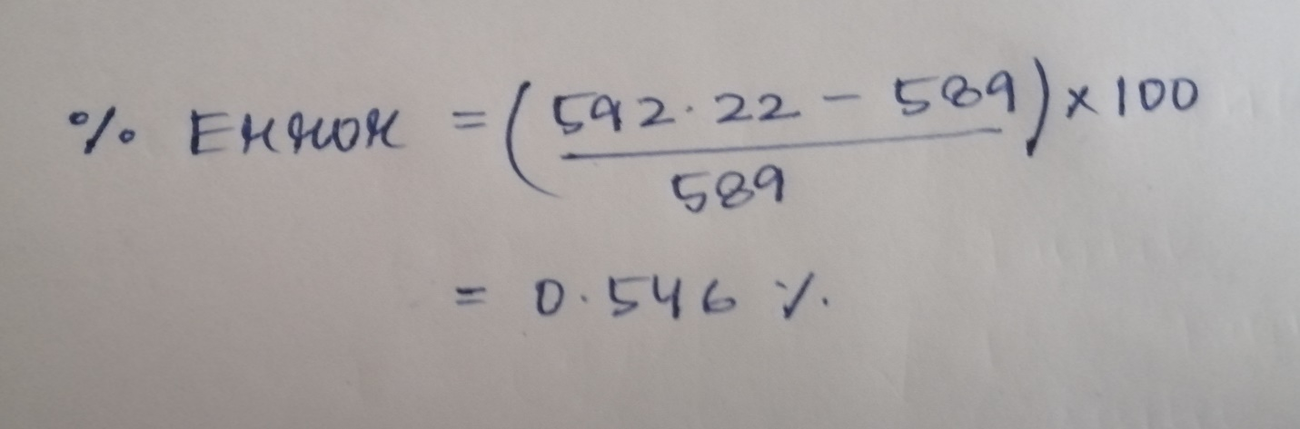

**RESULT:**

1.Wavelength of sodium light was found out to be 592.22 nm

2.Percentage error in measuring wavelength of sodium light was 0.546%

**By: Amogh Garg**

**2020UCO1688**

**COE(Section-3)**